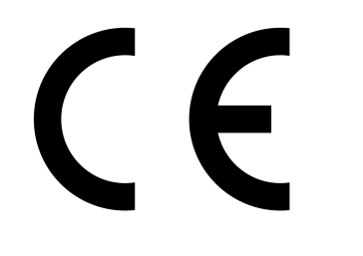
EC Declaration of Conformity

Morris & Perry Ltd
Gurney Slade Quarry
Radstock

The above manufacturer (as represented by the undersigned) declares that the following product/s conform to the provisions of the EU Construction Products Directive, in accordance with Annex ZA of BS EN 12620, current edition.
Product description:
Carboniferous Limestone (2/6, 4/10, 4/20 & 10/20 coarse single size) Aggregates for Concrete
Coarse: D/d ≤ 2 or D ≤ 11,2 mm and D/d > 2 or D >11,2 mm, Category G_{C}85/20 and G_{C}90/15

Particle shape: Declared Value Fl₁₅
Particle size: Designation 2/6, 4/10, 6/14, 4/20, 10/20 & 20/32mm
S/S Limestone
Particle density: Declared Value 2.70 Mg/m³ Typical
Cleanliness: Fines Quality Pass
Shell Content Pass SC₁₀
Resistance to Fragmentation/
Crushing: LA₂₅
Resistance to Polishing: PSV₃₇
Resistance to Wear: M_{DE}15
Composition/Content:
Chlorides <0.01% C
Acid soluble sulphates AS_{0.2}
Water soluble sulphates SS_{0.2}
Total sulphur <1.0% S
Rate of Hardening (Humus) Negative
Carbonate content >90.0% CO₂
Volume stability: Drying Shrinkage <0.040% WS
Water Absorption: 0.70% WA
Durability against ASR: Low Risk - Petrographic
Durability against Freeze Thaw: MS₅

These Aggregate products are compliant in accordance with the Assignation of Evaluation of Conformity under System 4, Table ZA.2, of BS EN 12620, current edition.

Full performance and usage applications detailed on specificdata sheets.

Signed:

General Manager

