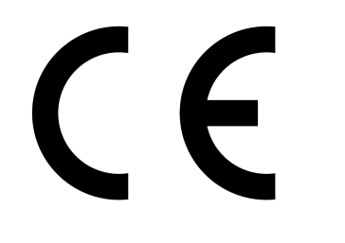
EC Declaration of Conformity

Morris & Perry Ltd
Gurney Slade Quarry
Radstock

The above manufacturer (as represented by the undersigned) declares that the following product/s conform to the provisions of the EU Construction Products Directive, in accordance with Annex ZA of BS EN 12620, current edition.

Product description:
Carboniferous Limestone (0/4 fine, 2/6, 4/10, 6/14, 4/20, 10/20 & 20/32 coarse single size) Aggregates for Concrete

Coarse: D/d ≤ 2 or D ≤ 11,2 mm and D/d > 2 or D >11,2 mm, Category G_{C}85/20 and G_{C}90/15

Fine: D ≤ 4mm and d = 0, Category G_{F}85

These Aggregate products are compliant in accordance with the Assignation of Evaluation of Conformity under System 4, Table ZA.2, of BS EN 12620, current edition.

Full performance and usage applications detailed on specificdata sheets.

Signed:

General Manager

